General Biology Year 11

Unit 2 – Solving problems to survive

Task 8: Practical – Specialised structures for nutrition in carnivores, herbivores, omnivores and parasites

|  |  |  |  |
| --- | --- | --- | --- |
| **Name:** | **Teacher:**  Mr Groznica | **Date:**  27/07/2021 | **Score:**  **/29** |

**Assessment type:** Science Inquiry - Practical

**Conditions**

Time for the task:

* **One hour in class assessment** – Observe skulls of carnivores, herbivores and omnivores to compare teeth structure and compare these with structures of parasites.

**Task weighting** – 5%

______________________________________________________________________________

**INTRODUCTION**

An animal’s diet helps shape the behaviour, evolution and anatomy of the species. The development and arrangement of teeth (dentition) reflects this best, but an organism’s skull evolves to suit its diet as well. The teeth and skull trends are so strong that palaeontologists (study the history and process of evolution by examining fossils, the preserved traces of long dead animals and plants) can often determine the diet of an extinct animal from nothing more than a few teeth or skull fragments.

***Teeth show diet***

The hardest and longest-lasting bone in the body is tooth enamel. The most common fossils are teeth, followed by jaws. Unlike other animals, mammals have only two sets of teeth, the first (often called ‘milk teeth’) erupts after birth. After puberty, a larger set, with more and bigger teeth to fill larger jawbones, emerges.

**Incisors** – are used to bite into food. In many species they are used as pincers for grasping or picking, both in feeding and in grooming.

**Canines** – are the sharpest teeth and are used for tearing apart food, stabbing and holding prey and as weapons in social displays or fighting.

**Premolars** – have a flat biting surface and are used for tearing and crushing food.

**Molars** – have a large flat biting surface and are used to grind, tear and crush food.

The size and shapes of these tooth types are correlated with the different diets of mammalian species.

***What do jaw bones tell us?***

Like teeth, jawbones help identify a mammal as carnivore, herbivore or omnivore. Carnivore jaws are attached so that they only open and close; the teeth can-not move from side to side. In contrast, herbivore jaws are fastened loosely; this side-to-side motion allows the animal to grind plant material with his molars. Omnivore jaws are more like carnivore jaws because, in general, omnivores eat fruit and seeds not grass and branches.

______________________________________________________________________________

**Aim -** In this activity you will compare specialised structures for nutrition in carnivores, herbivores, omnivores and parasites.

**PART A:** **Carnivores, herbivores and omnivores**

1. Circle and label each of the four main tooth types: using I for incisors, C for canines, P for premolars and M for molars. (2 marks)

1. Compare the teeth and jaw bones of the two mammal skulls displayed at the front of the classroom. Answer the following questions about each of the skulls.

Skull 1

1. In the box below, draw a labelled diagram of the teeth and the lower jaw bone (mandible) of the mammal. (3 marks)

1. Omnivore, carnivore or herbivore? _________________________________ (1 mark)
2. Describe the most prominent diagnostic features that support your hypothesis. Which tooth type (incisors, canines, premolars, molars) are most specialised (reflecting diet)?

(4 marks)

Feature 1

____________________________________________________________________________________________________________________________________________________________________________________________________________________________________________________________________________________________________

Feature 2

____________________________________________________________________________________________________________________________________________________________________________________________________________________________________________________________________________________________________

1. What do the jaw bones tell us about this mammal? Do they support your hypothesis?

(1 mark)

__________________________________________________________________________________________________________________________________________________

1. Hypothesised diet? _____________________________________ (1/2 mark)
2. Animal guess? _____________________________________ (1/2 mark)

Skull 2

1. In the box below, draw a labelled diagram of the teeth and the lower jaw bone (mandible) of the mammal. (3 marks)

1. Omnivore, carnivore or herbivore? _________________________________ (1 mark)
2. Describe the most prominent diagnostic features that support your hypothesis. Which tooth type (incisors, canines, premolars, molars) are most specialised (reflecting diet)?

(4 marks)

Feature 1

____________________________________________________________________________________________________________________________________________________________________________________________________________________________________________________________________________________________________

Feature 2

____________________________________________________________________________________________________________________________________________________________________________________________________________________________________________________________________________________________________

1. What do the jaw bones tell us about this mammal? Do they support your hypothesis?

(1 mark)

__________________________________________________________________________________________________________________________________________________

1. Hypothesised diet? _____________________________________ (1/2 mark)
2. Animal guess? _____________________________________ (1/2 mark)

Skull 3

1. In the box below, draw a labelled diagram of the teeth and the lower jaw bone (mandible) of the mammal. (3 marks)

1. Omnivore, carnivore or herbivore? _________________________________ (1 mark)
2. Describe the most prominent diagnostic features that support your hypothesis. Which tooth type (incisors, canines, premolars, molars) are most specialised (reflecting diet)?

(4 marks)

Feature 1

____________________________________________________________________________________________________________________________________________________________________________________________________________________________________________________________________________________________________

Feature 2

____________________________________________________________________________________________________________________________________________________________________________________________________________________________________________________________________________________________________

1. What do the jaw bones tell us about this mammal? Do they support your hypothesis?

(1 mark)

__________________________________________________________________________________________________________________________________________________

1. Hypothesised diet? _____________________________________ (1/2 mark)
2. Animal guess? _____________________________________ (1/2 mark)
3. Compare the teeth of the following three animals. Some animals have molars with large flat surfaces for grinding food. Canines can be equal in size to other teeth or slightly larger depending on diet.

Which skull belongs to whom? Identify the skull of the bear, dog and a pig. (1.5 marks)

**PART B:** **Parasites**

Tapeworms are flat segmented worms that usually live in the intestines of animals. Tapeworms are animals that have three stages of life. The stages include the egg stage, larvae stage, and finally the adult stage which is when eggs are produced. A fully matured tapeworm consists of a head, neck, and chain of segments called proglottids.

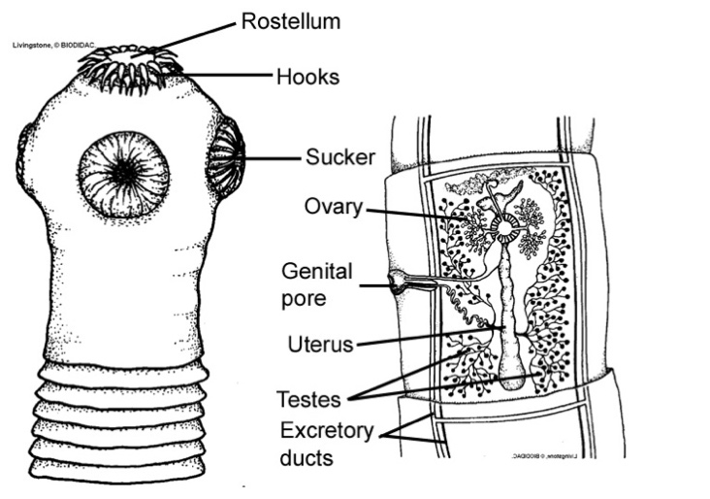

1. Observe the preserved tapeworm specimen presented at the front of the classroom. In the box below, draw a labelled diagram of the tapeworm. (3 marks)

1. Based on your observations about the physical structure of the tapeworm, propose how they obtain nutrients from the host? (1 mark)

__________________________________________________________________________________________________________________________________________________

1. How is this mode of nutrition different to how carnivores obtain their nutrients? (2 marks)

____________________________________________________________________________________________________________________________________________________________________________________________________________________________________________________________________________________________________

**References**

1. https://www.mainstreetsmiles.com/dental-and-skull-anatomy-of-carnivores-herbivores-and-omnivores/
2. https://animaldiversity.org/collections/contributors/anatomical_images/teeth_types/
3. http://www.lakesidenaturecenter.org/AOM%20-%20General%20-%20Mammal%20Skulls%20and%20Teeth.pdf
4. https://digitalcommons.unl.edu/cgi/viewcontent.cgi?referer=&httpsredir=1&article=1027&context=museummammalogy
5. <http://webprojects.oit.ncsu.edu/project/bio181de/Lab/nutrition/nutrition4.html#act3>
6. http://www.myfossil.org/wp-content/uploads/2017/04/PreLesson-2-Student-Worksheet-Tooth-Types-1.pdf
7. <http://cardiovasculargma.weebly.com/-lrmtaenia-saginata-tapeworm.html>

**END OF ASSESSMENT**